5.RECENZIA (review)

- je to krátky popis knihy, filmu, hry, počítačovej hry, výstavy, televízneho programu alebo iného druhu zábavy
- majú formu správy a zvyčajne sú určené na tlač alebo ako elektronické médium.
- Majú informovať čitateľov a odporúčať či daný materiál sa oplatí alebo neoplatí čítať, pozerať alebo kúpiť

ÚVOD: základné informácie, napr. názov, štýl, druh, scéna, autor
JADRO: skladá sa obvykle z dvoch odstavcov:
1. stručne dej v chronologickom poriadku
2. hodnotenie deja, postáv, osvetlenia, štýlu, grafiky, réžie
ZÁVER: slúži na vyjadrenie názoru autora o danom diele a odporučiť alebo odradiť čitateľov od jeho sledovania alebo čítania

PISATEĽ MUSÍ DAŤ JASNÉ STANOVISKO O KVALITE DIELA a tiež dôvody a príklady podporujúce jeho názor

JAZYK: prítomné časy, prídavné mená

Review
The Great Gatsby

The Great Gatsby is a novel written by Francis Scott Fitzgerald. It was written in 1925. The story is set in New York (Long Island) in the 20th century. This book has many illustrations. F. Scott Fitzgerald was writing the „Jazz age“ novels.
The plot begins a few years after the war, when Nick Carraway, a Yale graduate and World War I veteran from the Middle West who takes a job in New York as a bond salesman, comes to Long Island. Nick is a narrator of the story. He lives in West Egg behind young and wealthy Jay Gatsby. For Nick, the handsome, rich Gatsby seems to lead the perfect life. But beneath that shimmering facade Gatsby harbors an obsessive desire for the only thing he truly wants, but can never have – Daisy. As a young boy he was too poor and couldn‘t marry her. He did everything he could to fit in her society, which was ruthless and egoistic. They meet each other in Nick´s house. They fall in love again and they become a lovers. Daisy is married with Tom, but he doesn´t love her as much as his lover (Myrtle) in New York. Gatsby and Daisy decide to be together and they want to tell the true… In the end Gatsby dies because of his own mistake – he didn´t suspect that all the people could be so selfish! After the accident, when the car has struck and killed Myrtle, Daisy decide to stay with Tom, because she loves them both. Gatsby is killed by Myrtle´s husband, who thinks, that he killed Myrtle. But it wasn´t true…. It was Daisy!
I really like this book because it´s a great novel about the American society in 1920s and the only decent man there, Jay Gatsby. It’s clear that F. Scott Fitzgerald is a good writer because the novel is well-written in every way! I can only recommend.

Gatsby with Daisy The book is filmed by Baz Luhrmann.
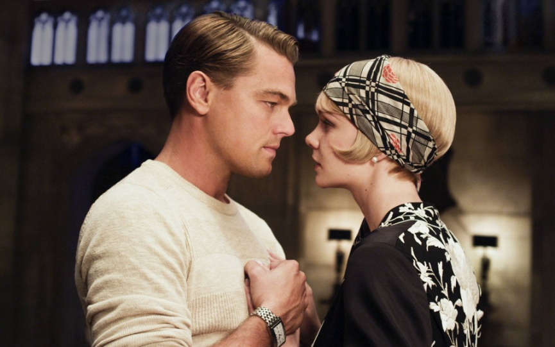
Nick Carraway
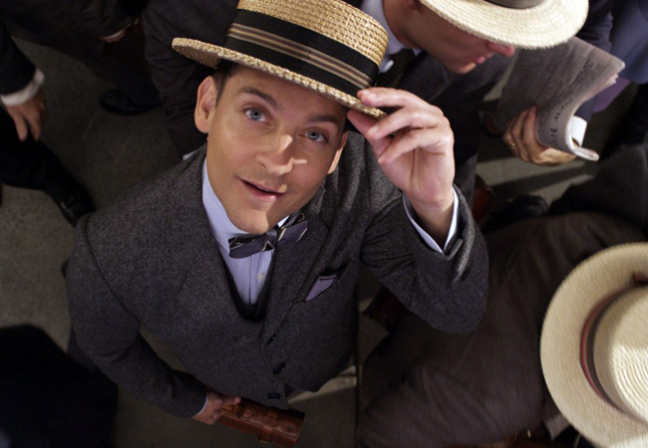

N. Imrichová, VII.O

